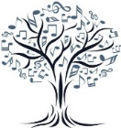-

**WALTHAM FOREST MUSIC SOCIETY**

**(President – Nelly Miricioiu)**

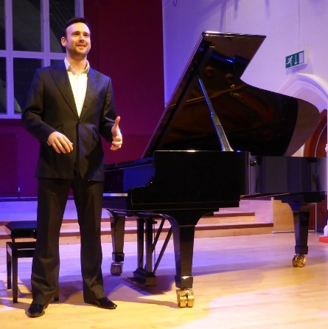

John Paul Ekins

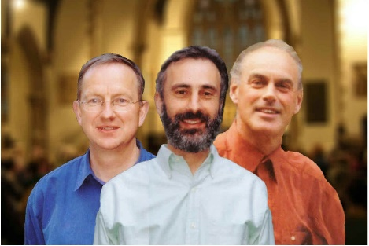

The Galliard Trio

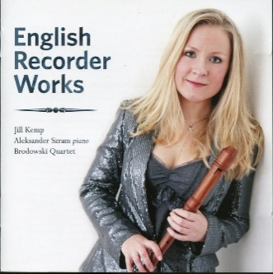

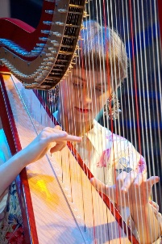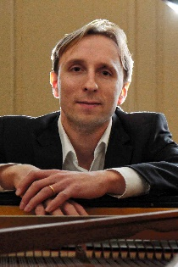

Jill Kemp

Helena Ricci

Aleksander Szram

67th Season (2023-24)

CALENDAR OF EVENTS

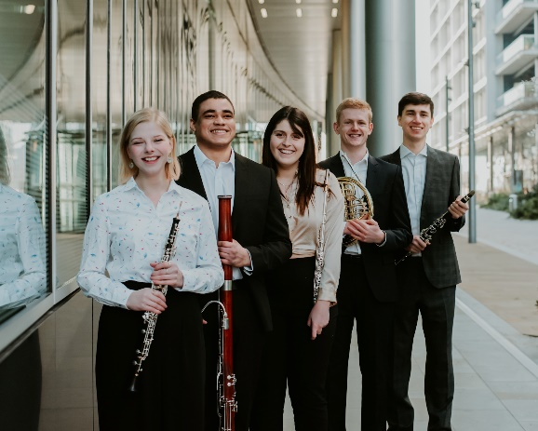

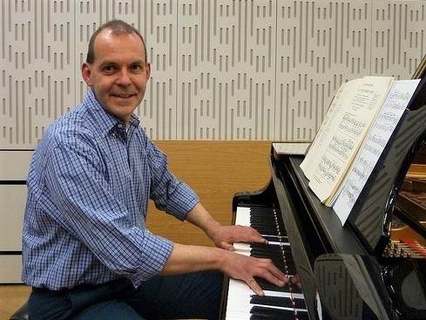

Paul Guinery

Ormonde Ensemble

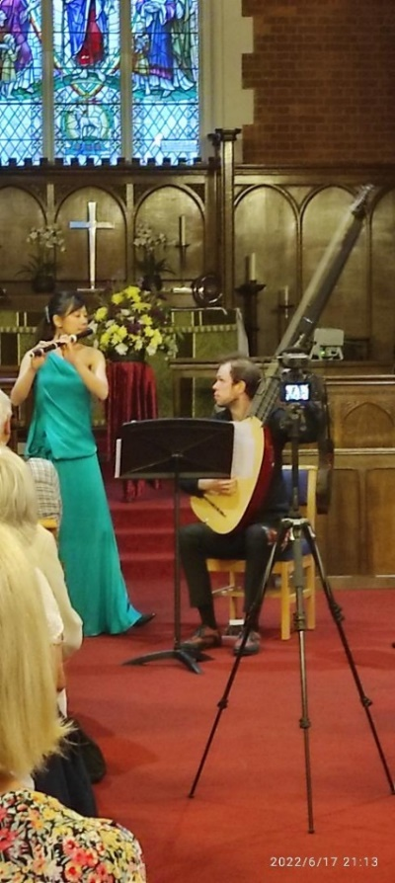2023 is a significant year in the history of the Waltham Forest Music Society. In April, after twenty-four years of service, Andrew Golds announced that he would not be seeking re-election for the post of chairman. At the end of last year, Andrew had resolved to take a less active role and had entrusted the smooth running of meetings to Ian Brown and Martin Hull so his decision was not altogether unexpected.

Each season combines live recitals with programmes of recorded music presented by members. Recitals are given in All Saints Church, Church Avenue, Highams Park, E4 9QZ, and evenings of recorded music are held in the adjacent hall. All events start at 7.30.

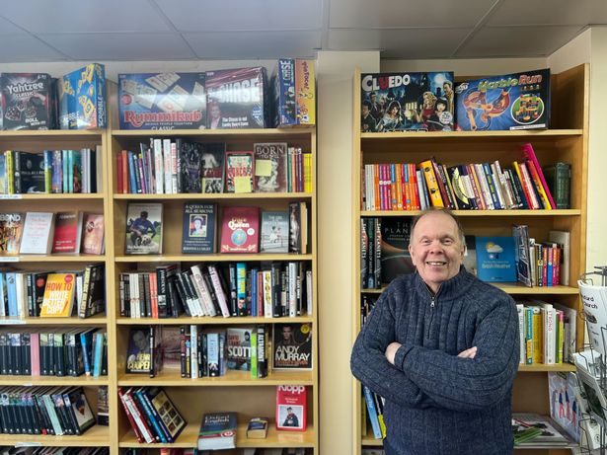

With the death of Gerald Verrier in 1999, Andrew, as a relatively new member, had been invited to step up to the plate to ensure that the Society, then known as the Forest Recorded Music Society, continued to function. At the time, he thought it would be a temporary appointment but he was to continue in post for nearly a quarter of a century!

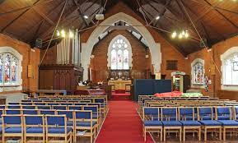The Society is sincerely grateful to Andrew for everything he has achieved during his tenure and, in particular, for introducing live recitals into each season’s programme of events. This decision undoubtedly enabled the Society to maintain its momentum and thrive at a time when listening to music on CDs in a church hall was not as popular a pursuit as it had once been and membership was steadily declining. From around forty in number when Andrew assumed the responsibilities of chairman, the Society has grown to a current membership of one hundred and twenty-one, the highest in its history. At the Annual General Meeting in July, Ian Brown was elected as his successor. Andrew will continue to take an active role in the Society and will serve in the important post of Treasurer while now being able to devote more time to managing V and A Books & Gifts with his wife Val. We all wish him well for a more relaxed future.

The 150th anniversary of Sergei Rachmaninoff’s birth is being celebrated this year. Although his output was relative small with only forty-five opus numbers and around sixty further compositions to his name, it is unfortunate that knowledge of his music may often be confined to a handful of popular works such as Prelude in C sharp minor, Piano Concerto No. 2 in C minor, Symphony No. 2 in E minor, and *Rhapsody on a Theme of Paganini*. The first evening of the season will combine the familiar with the less familiar in a programme of Rachmaninoff’s music suggested by members.

2023 also marks the 150th anniversary of a significant local event. On 17th November 1873 the Great Eastern Railway opened a temporary terminus at Chingford, where steam locomotives were able to replenish their water tanks from a farm pond! On the same date Hale End station, renamed Highams Park and Hale End in 1894, opened, as did Wood Street station. To commemorate this significant piece of local railway history, Andrew Golds will be presenting his programme of recorded music on 3rd November – *On the Right Track.*

As usual, the calendar includes the ever-popular Christmas Committee Choice evening during which members will be able to enjoy a selection of festive and non-festive music accompanied by wine and mince pies. Members’ Evening has been scheduled for the end of May rather than its usual June slot. Jane Harrington, Jane Jones and Peter Wilson will each be presenting their first programme of recorded music.

Six recitals will be held in All Saints Church; once again, the Society has engaged some first-rate musicians ranging from solo performers to ensembles including a piano and wind sextet.

We are delighted that on 5th April the internationally acclaimed soprano Dame Felicity Lott will be talking about her life and career. She visited the Society a number of years ago as a thunderstorm was raging so we hope that her arrival will be a little less dramatic on this occasion.

The dates of all the season’s events can be found in the middle of this booklet. There will be two CD sales during the year, the dates of which are indicated with a red asterisk in the calendar of events.

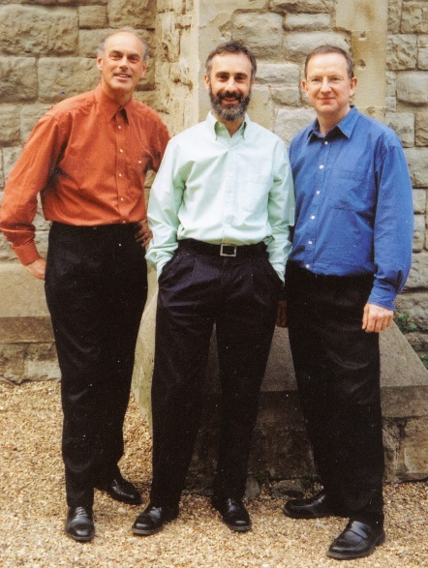

**6th October**

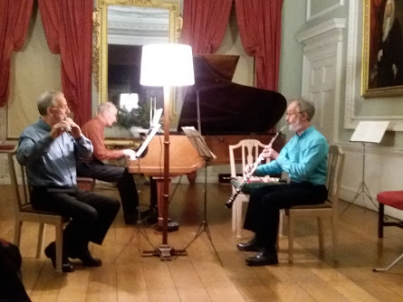The Galliard Trio has been performing in venues throughout southern England for the past forty-two years. It plays for music societies, clubs and charities in churches - including St. Olave’s near the Tower of London - art centres, National Trust properties, museums and other cultural centres. The Trio has played throughout the London area and home counties but this will be its first engagement in Waltham Forest, although flautist Andrew Morris played for a few years in the Forest Philharmonic Orchestra during the period when its conductor was Frank Shipway. The Galliard Trio has established a reputation for programmes of great variety. Its repertoire is wide, partly because of the different combinations of instruments available and partly because of the arrangements it has made of music by many composers. The members live within a short distance of each other in North London. They have recorded some of their favourite pieces on two CDs, copies of which will be available to buy during the recital’s interval.

Their programme will include one of Dvořák’s Slavonic Dances, Ravel’s Mother Goose, Stravinsky’s Pulcinella and music by Milhaud, Rachmaninoff, and Shostakovich.



**24th November**

John Paul Ekins was born in London and began playing the piano at the age of five, later graduating from the Royal College of Music and as a scholar at the Guildhall School of Music & Drama with first class degrees, studying with John Barstow and Charles Owen respectively. A winner of nineteen prizes at international competitions, he was honoured to be presented to Her Majesty Queen Elizabeth and enjoys a busy career of performing and teaching both around the UK and internationally. Career highlights include recitals at the Wigmore Hall and concerto performances at The Royal Albert Hall. In response to the Covid lockdown, he set up Cats, Chats & 88 Keys (www.youtube.com/CatsChats88Keys), an online concert series for maintaining a connection with audiences, which raised over £5,000 for the NHS in Spring 2020. With performances coming live from his home, the series, founded on a passionate belief that classical music is for everyone, was fuelled by a desire to instil in others his love for music. He shares his home with three quirky cats, who are never far from the music-making. JPE was the first artist engaged during the early days when our seasons began to incorporate live recitals and this will be his fourth appearance for the Society. His concert will include music by Mozart, Rachmaninoff and Schubert.

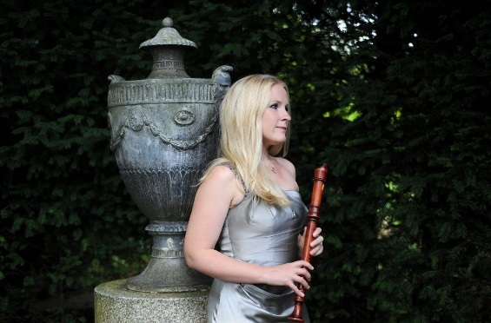

**22nd March**

Jill Kemp is passionate about raising the recorder’s profile and proving that it is an exciting and versatile instrument. As a soloist and chamber musician, her repertoire spans seven centuries and she regularly performs new commissions. Winner of numerous prizes, in 2007 she won the Royal Over-Seas League Wind Competition, the first recorder player to do so in its 64-year history. Jill has broadcast on the BBC, Classic FM and American, Italian and Polish television. Recital venues throughout Europe, the USA and South Africa include Carnegie Hall and the Queen Elizabeth Hall. She has performed with ensembles including Red Priest, the Brodowski Quartet and the LSO. Jill studied at the Guildhall School and Goldsmiths College, and with teachers including Michala Petri. Jill has given masterclasses throughout Europe and the USA, examined for Trinity Laban Conservatoire and adjudicated for the IBLA Grand Prize and Help Musicians UK. Since 2008 she has given masterclasses and concerts at Dartington International Summer School and Festival and is a consultant and examiner for TCL exams. Her work as a recording artist includes sessions at Abbey Road for Harry Potter and the Deathly Hallows. The Fantastic Mr. Fox, Philomena and The Grand Budapest Hotel.

Jill’s CD ‘English Recorder Works’ was released in 2013 on MMC records. Her disc of world premiere recordings with pianist Aleksander Szram, ‘Aztec Dances – New Works for Recorder and Piano’, was released in 2017 on Prima Facie Records.

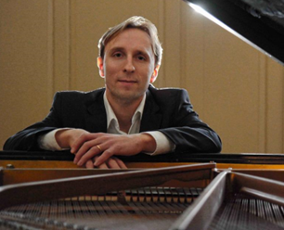Aleksander Szram specialises in performing music of the 20th and 21st centuries and has released several albums of contemporary repertoire on the Prima Facie label, including the Piano Concerto by Daryl Runswick, Inner Landscapes (Douglas Finch), A Land so Luminous (Kenneth Hesketh), and the album Aztec Dances. He has recorded for Nimbus with the flautist Wissam Boustany, and given premieres of works by Frederic Rzewski, Dai Fujikura, Haris Kittos, Edward Gregson, Nicola LeFanu, Sam Hayden and David Bedford, among others. As pianist in the ensemble Gemini, he has recorded three albums with Métier, including works by Jonathan Harvey, Sadie Harrison, Huw Watkins, Philip Grange, and the first recording of Mandala 3 by David Lumsdaine. As well as Gemini, Aleks works with the Continuum Ensemble, Lontano and rarescale.  He has performed in more than forty countries over six continents, on BBC Radio 3, Classic FM, Channel 4, and Colombian and Lebanese television. Since February 2023 he has been Director of Music at Trinity Laban Conservatoire of Music and Dance, having previously managed the BMus programme.

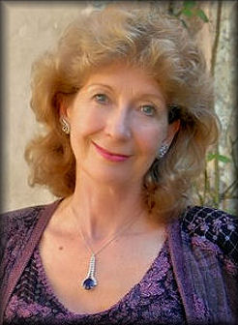

**5th April**

Universally known as ‘Flott’, Felicity Lott was born in Cheltenham and read French and Latin at Royal Holloway College, London University, with the intention of becoming an interpreter. During a stay in France, she took singing lessons at the Conservatoire of Grenoble and returned to London in 1969 to study singing at the Royal Academy of Music, gaining an LRAM and winning the Principal’s Prize.

Felicity made her debut at the English National Opera as Pamina in Mozart’s Magic Flute in 1975 and performed the debut of Henze’s opera We Come to The River at the Royal Opera House in 1976. In that year she also began her long relationship with Glyndebourne. After rejecting her for the Chorus three times, they offered her the role of the Countess in Capriccio on tour, and in 1977 she appeared at the Festival for the first time, as Anne Trulove in Stravinsky’s The Rake’s Progress. Her many roles include the Marschallin (Der Rosenkavalier), Arabella (Arabella), Christine (Intermezzo), Countess Almaviva (Le Nozze di Figaro), Fiordiligi (Cosi Fan Tutte), Donna Elvira (Don Giovanni), Ellen Orford (Peter Grimes), The Governess (The Turn of The Screw), Lady Billows (Albert Herring), Louise (Louise), Blanche (Les Dialogues des Carmélites) and Elle (La Voix Humaine).

In 1993 Felicity sang the title role in Lehar’s Merry Widow with Glyndebourne Festival Opera on a recording for EMI, having sung the role on stage in Nancy and Paris in the 1980s. In 1999 she appeared as Rosalinde in Johann Strauss’s Die Fledermaus in Chicago and as Hélène in Offenbach’s La Belle Hélène at the Chatelet in Paris. In the 2004/5 season she appeared as Offenbach’s La Grande Duchesse de Gérolstein.

As a concert artist Felicity has worked under such conductors as Carlos Kleiber, Georg Solti, Bernard Haitink, James Levine, Andre Previn, Neeme Järvi, Klaus Tennstedt, Andrew Davis, Kurt Masur, Franz Welser-Möst and many more. Her repertoire includes works by Handel, Bach, Haydn, Mahler, Brahms, Elgar and Walton.

She has received honorary doctorates at the Universities of Sussex, Loughborough, London, Leicester, Oxford and at the Royal Conservatoire of Scotland. She was awarded the titles Officier dans l’Ordre des Arts et des Lettres by the French government in 1990 and Chevalier dans la Légion d’Honneur in 2001. In 1990 she was made a CBE and in 1996 she became a Dame Commander of the British Empire, while in 2003 she was awarded the title of Bayerische Kammersängerin.

Tonight, Dame Felicity will be talking about her life and career as one of the most esteemed sopranos of recent times.

8th September **Rachmaninoff’s 150th Birthday Celebration**

The season opens with an evening celebrating the life of this great Russian composer, pianist and conductor in a programme of well-known and unfamiliar pieces, many of which have been chosen by members.

22nd September **YDHTBJ… Lionel Lewis**

…but Meyerbeer, Copland and Gershwin were! The first cryptic title of the season.

6th October **Recital – The Galliard Trio**

Andrew Morris {flute and piccolo}, Martin White {oboe and cor anglais},

Alec Forshaw {piano and bassoon}

**The series gets off to an exciting start with a recital including pieces byDvořák, Milhaud, Ravel and arrangements of songs by Rachmaninoff.**

20th October **\* Over the Hills and Far Away Michael Gammie**

Michael’s musical memories of the 50s and 60s

3rd November **On the Right Track Andrew Golds**

**[**

Music to celebrate one hundred and fifty years of the Chingford Line.

24th November **Recital – John Paul Ekins {piano}**

**John Paul will be making his fourth visit to the WFMS for a programme**

**which will feature music by Mozart, Rachmaninoff and Schubert.**

1st December **Off the Beaten Track John Farrell**

Agreeable, tuneful music in the lighter vein

15th December **Christmas Committee Choice**

The festive pre-Christmas evening featuring a mixture of seasonal and not-so-seasonal music chosen by the Committee. Complimentary wine, soft drinks, mince pies and savoury snacks will be available to enjoy during the evening.

5th January **With Snow on their Boots Andrew Dalton**

Music from Old Russia

19th January  **Recital – Helena Ricci** **{harp}**

**The welcome return of this outstanding harpist who will be delighting us with pieces from her début solo album ‘Anima’, due to be released in autumn 2023. An evening not to be missed.**

2nd February **Miri It Is – Or Is It?**  **Peter Wilson**

Music to raise a smile or produce a tear.

16th February **The Joy of Discovery Len Wright**

Another in the series of programmes in which Len will play a selection of pieces he has encountered during a lifetime of discovering classical music.

1st March **Pease Pudding Hot Jane Jones**

Works by Tchaikovsky, Satie, Coleridge-Taylor and many others that have held significance for Jane over the years, from her 60s childhood to the present day.

15th March **Favourites from my Collection**  **Barbara Humm**

Music from Tomaso Albinoni to Debbie Wiseman

with a great many others in between.

22nd March **Recital – Jill Kemp {recorders} Aleksander Szram {piano}**

**Set aside memories of the treble recorder as an instrument of torture which**

**you were forced to play at school. Jill will demonstrate how exciting and versatile recorders can be in her programme which includes a piece requiring two to be played simultaneously!**

5th April  **Dame Felicity Lott**

**The WFMS is delighted to welcome back Dame Felicity for another evening in which she will talk about her life and career as an internationally-renowned soprano whose engagements have taken her to many of the world’s most famous opera houses and concert venues.**

19th April * **Humour in Music? David Mears**

A specially compiled selection of music designed to elicit a chuckle…..or not.

3rd May **Recital – Ormonde Ensemble**

Cara Houghton {flute}, Helena Mackie {oboe}, Alec Ross {horn},

Bruce Parris {bassoon}, Isaac Prince {clarinet}, Jasmine Allpress {piano}

**A programme including Mozart’s Quintet for Piano and Winds in E flat, a sextet by Poulenc and music by Price, Vinter and Fauré.**

17th May **See the Music - Hear the Dance Jane Harrington**

A programme illustrating forms of dance from ballet to flamenco plus some others along the way.

31st May **Members’ Evening**

The annual evening of music chosen by members who have not presented a full programme during the season.



14th June **Recital - Paul Guinery {piano}**

**What better way to spend a summer’s evening than in the company of pianist and broadcaster Paul Guinery for a programme of music combining**

**the light-hearted with the slightly more serious.**

28th June **Nowt So Queer as Folk Martin Hull**

Martin’s varied programme will illustrate how composers have incorporated folk tunes into their compositions.

12th July **Annual General Meeting**

The 67th season draws to a close with the Annual General Meeting of members. The formal business of the evening will be accompanied by complimentary wine, soft drinks and food.

**Chairman Treasurer**

**Ian Brown 07801 102781 Andrew Golds 020 8531 2938**

**Vice Chairman**

**Lionel Lewis**

**Committee Members**

**Malcolm Billingsley Michael Gammie Jane Harrington**

**Martin Hull David Mears**

To ensure the smooth running of the Society, the Committee will meet regularly throughout the year. Should you have any issues which you would like to be discussed, please contact Ian, Andrew or a committee member.



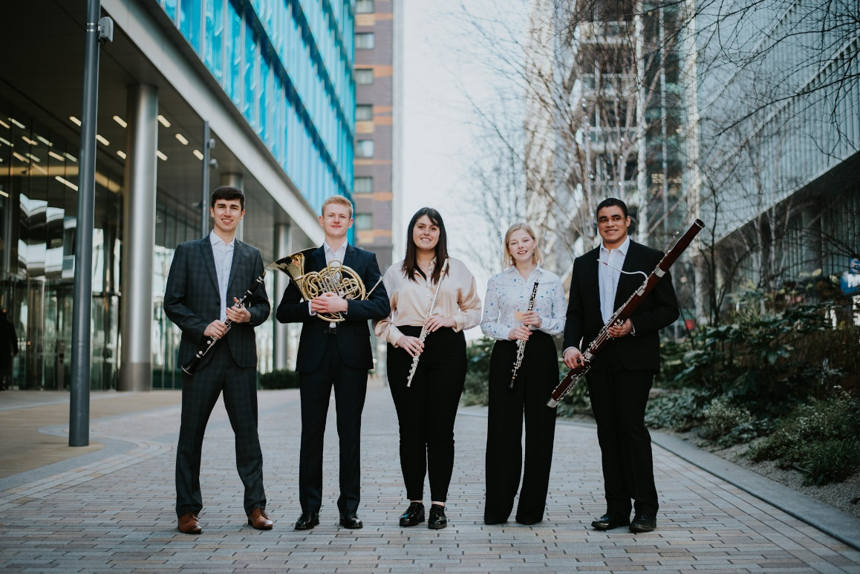

***3rd May***

The Ormonde Ensemble is a creative and dynamic wind quintet comprising postgraduate musicians from the Royal College of Music and the Royal Academy of Music who have a collective passion for seeking out and performing lesser-known and under-represented works, in addition to some of the standard elements of the quintet repertoire.

Ormonde Ensemble has given numerous recitals at various locations around England, including prominent venues in London, Bristol, Aylesbury, Bedford and Colchester. The quintet shares a strong commitment to education and outreach work and has recently been accepted onto Wigmore Hall’s acclaimed Chamber Tots Training and Development Scheme, through which it will develop new skills for planning and delivering workshops for early years children and their parents or carers.

Individually, the ensemble’s members have played with such orchestras as the Royal Philharmonic, Royal Liverpool Philharmonic, London Philharmonic, Philharmonia, BBC Concert Orchestra, BBC National Orchestra of Wales, Ulster Orchestra, Royal Opera House, Britten Sinfonia and the London Mozart Players. Education and outreach projects have included Live Music Now, LSO Discovery, LPO Open Sound, Neville Holt Opera and Royal Scottish National Orchestra.

There is a long-standing rapport between the players, with three of their founding members having met in the National Youth Orchestra of Great Britain. The group draws upon a wide range of educational backgrounds, with its members having studied at the Universities of Oxford, Cambridge and Birmingham, the Royal Northern and Royal Welsh Colleges of Music and the Sibelius Academy before coming together in London to form the quintet.

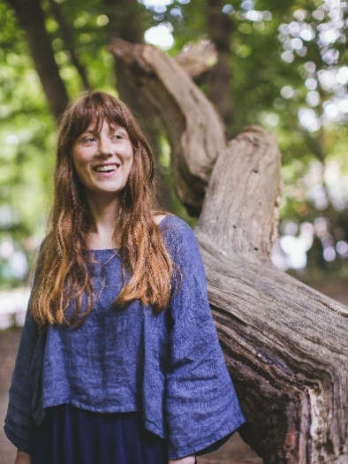Originally from Bath, Jasmin Allpress began playing the piano at six years of age and continued her studies at Chetham's School of Music at sixteen, studying with Peter Lawson and Graham Caskie. Jasmin completed her Bachelor degree on the 'Joint Course', studying at both Manchester University and the Royal Northern College of Music with Frank Wibaut and Helen Krizos. She is now completing a Masters in Piano Performance at the Guildhall School of Music and Drama in London under Martin Roscoe.

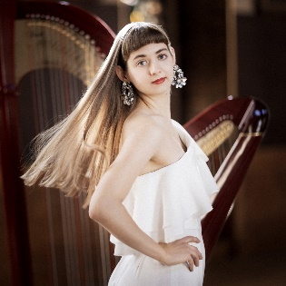

**19th January**

Helena Ricci is a trailblazing harpist praised for her expressive, dynamic playing and captivating stage presence. She is a City Music Foundation Artist, Stoller Hall Emerging Artist and former Hattori Foundation Senior Awardee, the first harpist ever to win this combination of awards.

Recent solo highlights include concerts at St Martin-in-the-Fields, the Royal Opera House, for the London Symphony Orchestra Discovery series, a soloist in Ravel's Introduction & Allegro at the Wigmore Hall and playing for His Majesty King Charles III. She took part in the Encuentro de Santander, Philharmonie der Animato European concert tour, Britten-Pears Young Artist “Composition & Performance course”, MDW Tuning In! and Guildhall Creative Entrepreneurs programmes. Helena is an alumna of the Guildhall School of Music & Drama where she studied with Imogen Barford and graduated with the highest honours.

Helena gave the first recital of the Society’s 2022-23 season and we are delighted to welcome her back this season for a concert which will form part of her UK tour. She will be playing pieces from her debut solo album Anima due to be released this autumn and copies will be on sale during the interval. Her programme will include, among other harp gems, works by J.S. Bach, Franz Liszt, Robert Schumann, Philip Glass, Elena Kats-Chernin and Erik Satie.

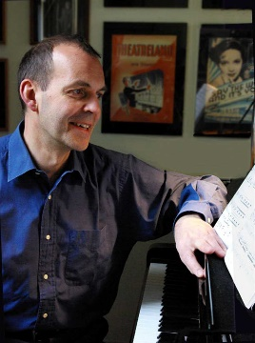

 **14th June**

Paul Guinery may be familiar to many as an announcer and broadcaster on BBC Radio 3, for which station he has hosted a variety of programmes such as Concert Hall, Your Concert Choice, Sacred and Profane and Choirworks, as well as presenting live Proms. He is also a freelance BBC radio newsreader.

Paul studied piano at the Royal College of Music and has since been widely active as a soloist, accompanist and chamber-music performer, as well as a broadcaster. In recent years he has explored music ‘on the lighter side’, particularly the richly rewarding, but nowadays neglected, treasury of English light music composed between the wars and on into the 1950s. Drawing on his own extensive sheet-music collection, Paul has recorded two CDs, with a third soon to follow, featuring solo piano works by Richard Addinsell, Haydn Wood, Billy Mayerl, Eric Coates, Ivor Novello, Madeleine Dring, Vivian Ellis and Edward German, amongst others. These have been aired on Radio 3, reflecting the BBC’s former role as a great champion of light music from its very early days.

Paul’s nostalgic recital will highlight this beautifully crafted, highly melodic repertoire to which more ‘serious’ composers such as Bax, Quilter and Scott occasionally contributed. The evening will include a virtuoso solo performance of Addinsell’s Warsaw Concerto, itself an affectionate tribute to Rachmaninoff.

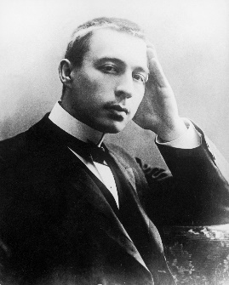

A photograph from 1906

Sergei Vasilyevich Rachmaninoff {1873 – 1943}

Rachmaninov or Rachmaninoff? The composer favoured the ‘ff’ spelling and insisted it should be used in contracts, correspondence, etc. after he had emigrated to America. The last letter of his name in Cyrillic Russian (Серге́й Васи́льевич Рахма́нинов) is pronounced as an ‘f’ rather than a ‘v’ so, although it may now seem strange to music lovers who have been accustomed to the ‘v’, the correct spelling is ‘ff’. Research suggests his family, part of the Russian pre-revolution bourgeoisie, adopted the ‘ff’ spelling on leaving Russia for the West.

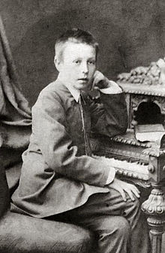

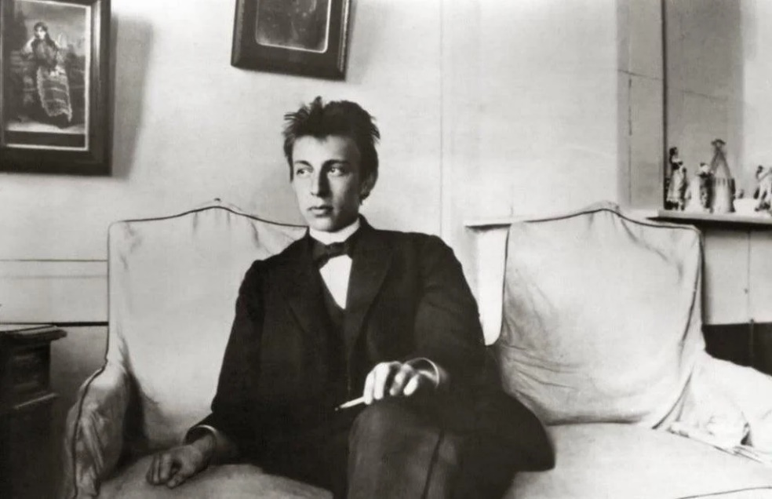On April 1st 1873, on a large estate near Novgorod, Sergei was born to a wealthy family, the fourth of six children. He received his early musical education from his mother before studying at the St. Petersburg and Moscow Conservatories where he was taught by Arensky, Taneyev and Tchaikovsky. He graduated in 1892, winning the Gold Medal for his opera, Aleko, which was highly praised by Tchaikovsky who promoted it to the Bolshoi Theatre in 1893. At the age of nineteen he composed the Prelude in C sharp minor which became his calling card. Its popularity increased to such an extent that in time he grew tired of the piece and once said, ‘Many, many times I wish I had never written it.’ The premiere of his First Symphony in 1897 was a disaster, thanks in part to the conductor, Glazunov, allegedly being drunk on the podium. Rachmaninoff fell into a state of depression which lasted for three years, during which he suffered from writer’s block and composed almost nothing. A course of hypnotherapy lead to his recovery and the first completed work to appear after this unproductive period was the Second Piano Concerto which was given its first performance in November 1901.

An unusually unkempt Rachmaninoff aged 17

Rachmaninoff aged 10

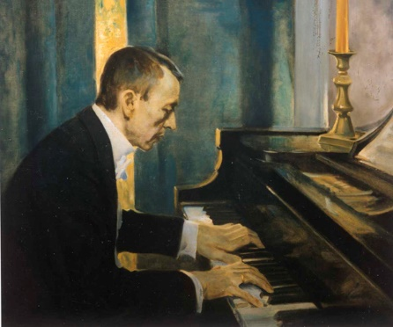The Revolutions of 1917 signalled the end of Rachmaninoff’s Russia. The confiscation of his beloved home, Ivanovka, by communist authorities earlier in the year, further alienated him from the Bolshevik movement and his concert performance in Yalta on 5th September was to be the last in his homeland. Towards the end of the year, he received an offer to perform a series of recitals in Scandinavia and immediately accepted, seeing this as an opportunity to obtain permits so he and his family could leave the country. In December they departed St Petersburg for the Finnish border from where they travelled to Helsinki on an open sled. Eleven months later, the Rachmaninoffs relocated to the United States of America.

Painting by Charles Chambers

Rachmaninoff's life as a touring performer and the demanding schedules that came with it, caused his compositional output to slow significantly. In the twenty-four years between his arrival in the USA and his death, he completed just six new pieces: the Fourth Piano Concerto, *Three Russian Songs*, *Variations on a Theme of Corelli, Rhapsody on a Theme of Paganini*, the Third Symphony and *Symphonic Dances.* He admitted that by leaving Russia, *‘I left behind my desire to compose: losing my country, I lost myself also’.*

At six foot six tall, it’s believed the composer may have had Marfan syndrome, which led to many medical ailments and complications throughout his life, including back pain, arthritis, eye strain and bruising of the finger tips. He possessed very large hands which could span the interval of a 13th on the piano keyboard. However, an article in the Journal of the Royal Society of Medicine suggested that he may have had acromegaly which would possibly have accounted for the stiffness Rachmaninoff experienced in his hands, for the repeated periods of depression he endured throughout his life, and could have possibly even been connected to the melanoma with which he was diagnosed near the end of his life.

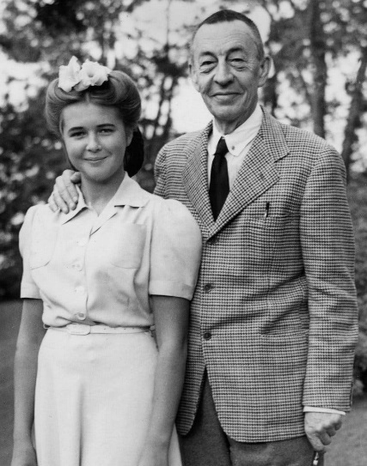The sounds of Russian bells were with Rachmaninoff from his earliest days. In his reminiscences, he wrote: ‘All my life I have taken pleasure in the differing moods and music of gladly chiming and mournfully tolling bells. This love for bells is inherent in every Russian. One of my fondest childhood recollections is associated with the four notes of the great bells in the St Sophia Cathedral of Novgorod, which I often heard when my grandmother took me to town on church festival days. The four notes were a theme that recurred again, four silvery weeping notes, veiled in an ever-changing accompaniment woven around them. I always associated the idea of tears with them’. The effect of bells is often present in his music, e.g. the First Suite for two pianos, the opera The Miserly Knight, the C sharp minor Prelude, the Second Symphony and in the choral symphony The Bells.

In his final years, Rachmaninoff opined that ‘music is enough for a whole lifetime – but a lifetime is not enough for music.’ Today, his popularity cannot be doubted but, in 1954, eleven years after his death, the Grove Dictionary of Music and Musicians prophesied obscurity in an assessment which dismissed his music as ’monotonous in texture’ ... consisting ‘mainly of artificial and gushing tunes’ and predicted that ‘The enormous popular success some few of Rachmaninoff’s works had in his lifetime is not likely to last, and musicians never regarded it with much favour’. Now, one hundred and fifty years after his birth, he cannot be regarded as anything but one of the greatest composers who spanned the 19th and 20th centuries and his music continues to delight and uplift many a concert-goer and music lover.

A rare photograph of a smiling Rachmaninoff, here posing with his grand-daughter Sophie in 1942.

Igor Stravinsky once quipped that he was ‘a six-and-a-half-foot-tall scowl’. However, he went on to say ‘He was an awesome man…his silence looms as a noble contrast to the self-approbations which are the only conversation of all performing and most other musicians. And, he was the only pianist I have ever seen who did not grimace. That is a great deal’.

The Waltham Forest Music Society is affiliated to the

Federation of Recorded Music Societies and is supported by

V and A Books & Gifts, 2 Bank Buildings, The Avenue,

Highams Park E4 9LE

The Society is grateful to both the Hale End and Highams Park South,

and Hatch Lane and Highams Park North Community Ward Forums

for their sponsorship of this season’s recitals.

New members are able to join the Society at a reduced rate for the first year of their membership. The reduced subscription has been set at £15 for the 67th season. A form for new members is included with this booklet and further membership enquiries can be made by contacting Ian Brown. Current members

are not required to complete a form when paying their 2023-4 subscription.

[wfmslondon@gmail.com](mailto:wfmslondon@gmail.com)

The Society’s Facebook page is regularly updated with WFMS news and information about local events.

facebook.com/WFMSLondon



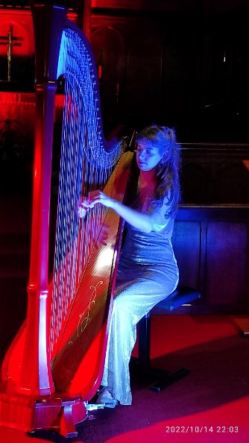

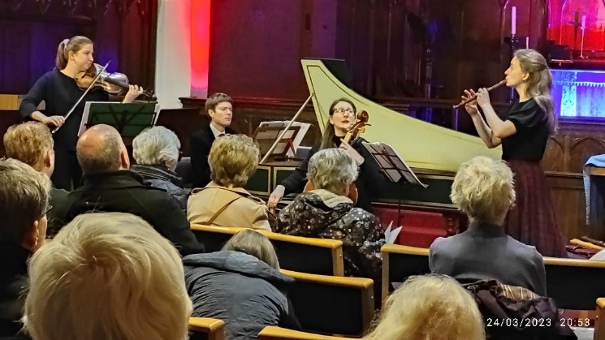

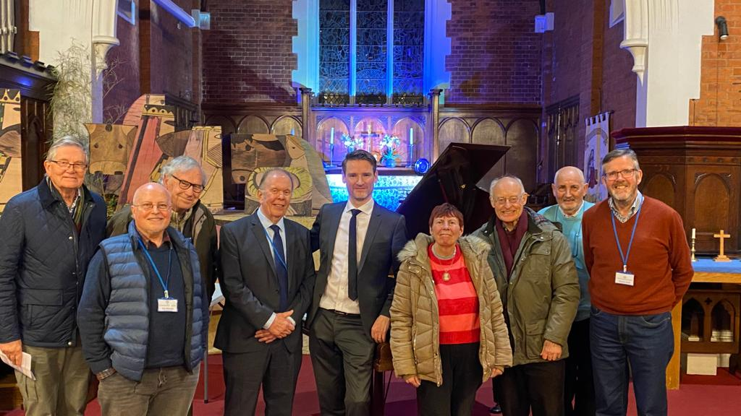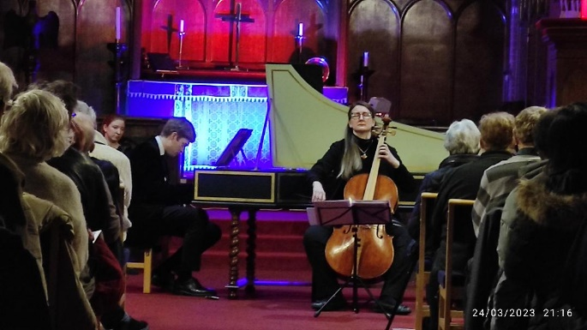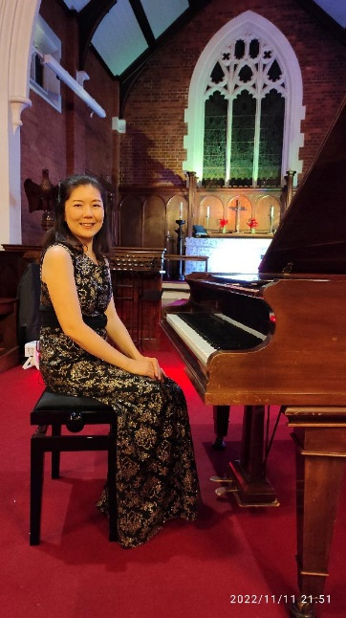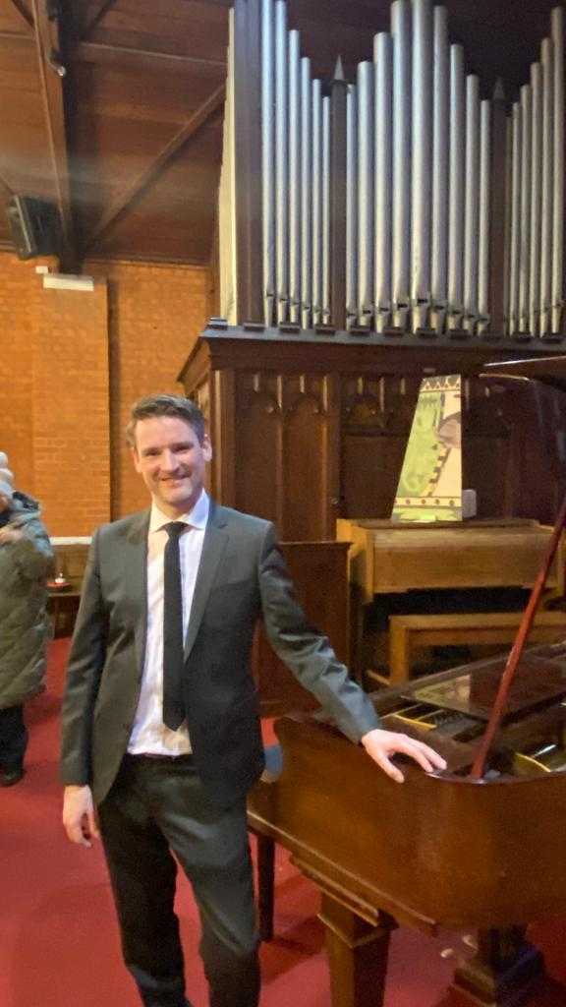

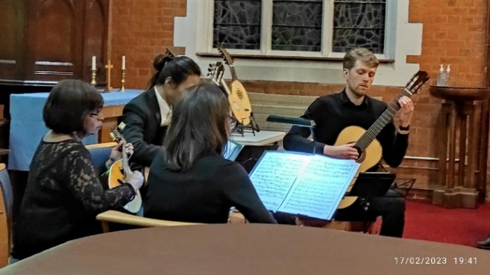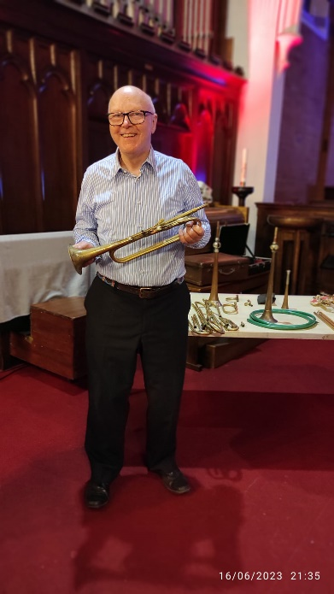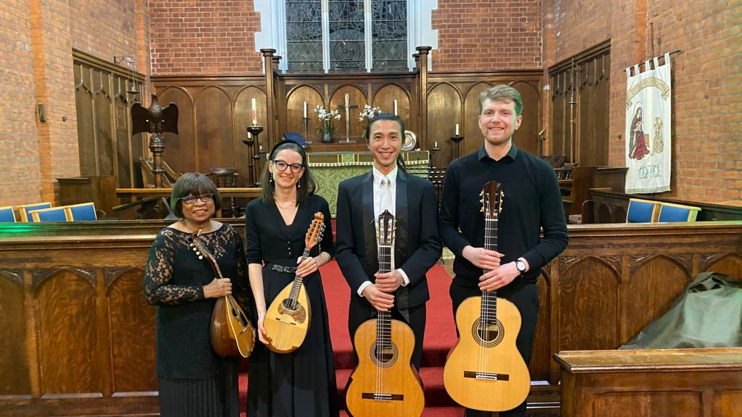

Memories of the 66th season’s recitals

